Maryland Evaluation & Treatment Services (METS)

Community Detention
AIM
Participant Manual

Contents
MCASP Case Management Participant Manual Versioning 3
Accessing METS 4
Course Objectives: 4
The ASSIST and METS Data Exchange 5
Creating a New Client 5
Contacts (Bidirectional Messaging) 5
Accessing METS 6
Logging in to METS 6
Finding an Existing Client 7
Creating a New Client in METS 10
Logging Out of METS 10
Accountability Incentive Management in METS 11
Course Objectives: 11
Accountability & Incentives Management (AIM) Screen 12
Document a CD Sanction 12
Deleting a Record 13
Requesting an Override to Modify the Response 14
Generate a Report in METS 15
DJS Contacts (Bidirectional Messaging) 18
Appendix A – Graduated Response Grid (Community Detention) 19

MCASP Case Management Participant Manual Versioning

Version | Date | Created by | Organization | Updates
1.0 | 6/10/15 | Kathleen Lester | University of Maryland | Initial Draft TSP

Accessing METS

Course Objectives:

At the end of this module, the trainee will be able to perform the following:

- Understand the data exchange between ASSIST and METS
- Access the METS application
- Locate a youth in METS
- Log out of METS

The ASSIST and METS Data Exchange

Creating a New Client
ASSIST
- Client Profile
- Legal Information
- Open Folder (trigger)
- Push Client Profile data to METS
METS
- Receives client information
- Creates a client in SMART
Data pushed
To METS
Paper
Referral from Police

Contacts (Bidirectional Messaging)
Contacts created in ASSIST are sent and stored in METS
Contacts created in ASSIST are sent and stored in METS
METS
- Receives and stores contact
- Create Contact in METS
ASSIST
- Create Contacts – pushed to METS
- Stores METS Contacts

Accessing METS

Logging in to METS

METS is a web based application and can be accessed anywhere that the internet is accessible.

- Using Internet Explorer type in https://mddjs.witsweb.org/ or click on the METS Icon from your desktop.

2. On the METS Login screen type your user name and password and click “Go.”

- Then type your PIN number and click “Go.”

- You will be navigated to the METS Home Page. Look for new Announcements about any scheduled system down time or known issues with METS.

Finding an Existing Client

There are two ways in which to find your clients in METS: 1) through the Caseload Summary screen, or 2) through the Client Search.

Finding Clients Using the Caseload Summary Module

The Caseload Summary is your springboard to easily finding your clients in METS. All case folders are sent from ASSIST to METS and any open folder assigned to you in ASSIST should display here on the Caseload Summary screen. (Note: at this time, only cases created through the Intake process are linked between ASSIST and METS, therefore clients manually created in METS (IC Receiving, etc.) may not display on the Caseload Summary module and can be found via the Client Search module. It is anticipated that by April 2015 all clients will be migrated and linked between ASSIST and METS.)

- From the Home Screen, click Caseload Summary.

- The Caseload Summary default displays all open folders (as assigned in ASSIST) for the individual logged into METS.

- The list can be modified by changing the search criteria and clicking Go.
- To search for a coworker’s caseload, begin typing the last name of the coworker in the Staff field, until that person’s name displays as an option in the Staff list.

- Then select the staff member and click Go to see his/her list of clients.

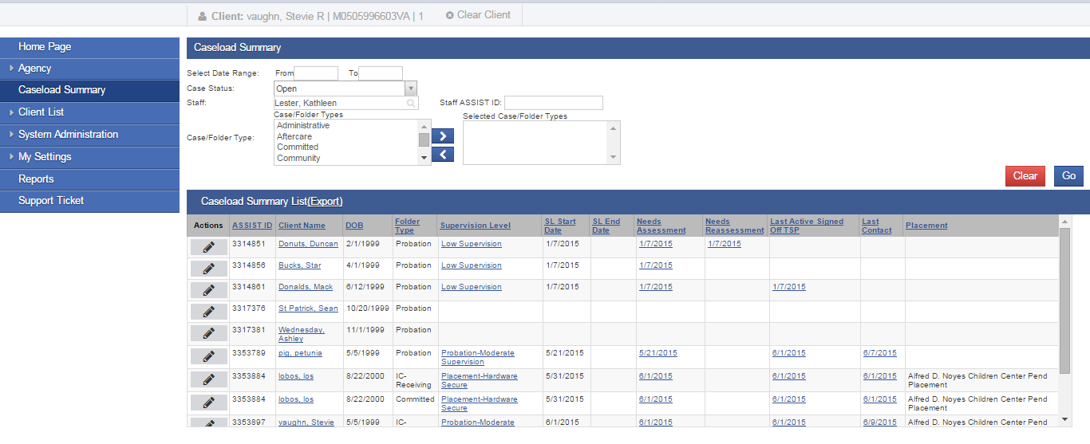
- The list can also be modified by changing other search criteria and clicking Go:
    - Case Status – changes the clients displayed by the status of their case (open, closed or deleted)
    - Case/Folder Type – changes the clients displayed by the case/folder type – probation, aftercare, administrative, committed, community, etc.

- The Caseload Summary provides quick information about each case, including:
- The ASSIST ID – this is the ASSIST ID associated with this client.
- Client Name – this displays the last name, first name of the client. Additionally, this field is a hot link to the Client Profile Screen.
- DOB – this displays the client’s date of birth.
- Folder Type – this displays the folder type. If there are more than one folder type opened and assigned to you, they will display here.
- Supervision Level – this displays the current active supervision level (where there is a start date and no end date)
- SL Start Date – displays the Supervision Episode Start Date
- SL End Date – displays the Supervision Episode End Date
- Needs Assessment – displays the most recent Needs Assessment associated with the Supervision Level (if no Needs Assessments have been completed it will be blank)
- Needs Re-Assessment - displays the most recent Needs Re-Assessment associated with the Supervision Level (if no Needs Re-Assessments have been completed it will be blank)
- Last Active Signed Off TSP – displays the last active signed and finalizedTSP associated with the Supervision Episode
- Placement – lists the name of the placement if the child has been admitted to a placement.
- Last Contact – displays the date of the last “Contact”. Note: this only displays the Date of Last Contact for field contacts, the Date of Last Contact for Community Detention staff does not display here.

- To access a client’s record, click on any of the hotlinks associated with that client to go to that specific module.

Finding Clients Using the Client Search Module

- From the Home Screen, click Client List.
- Enter the ASSIST PID in the Agency Client ID field or the Other Number field.
- Click .

- All clients with the ASSIST PID entered will be listed below.
- It is important to review the client’s profile and demographic information, prior to moving on to other modalities. To review the Client Profile, click the pencil icon to the left of the client listed to display the actions list, then select Profile.

Reviewing the Client Profile in METS

The following information is prepopulated from ASSIST: First Name, Last Name, Gender, DOB, SSN, Agency Client ID, Zipcode and Address. This data is pushed from ASSIST to METS to initiate the record in METS.

- Review the demographic information for accuracy.
  - If any of the following fields are inaccurate, return to ASSIST to update the information: First Name, Last Name, Gender, DOB, SSN, Agency Client ID.

Note: ASSIST is the record of State and all information must be updated in ASSIST, where update messages are sent to METS to update records. Only address should also be updated in METS. All demographic information updated in ASSIST (except Address) will be updated in METS automatically.

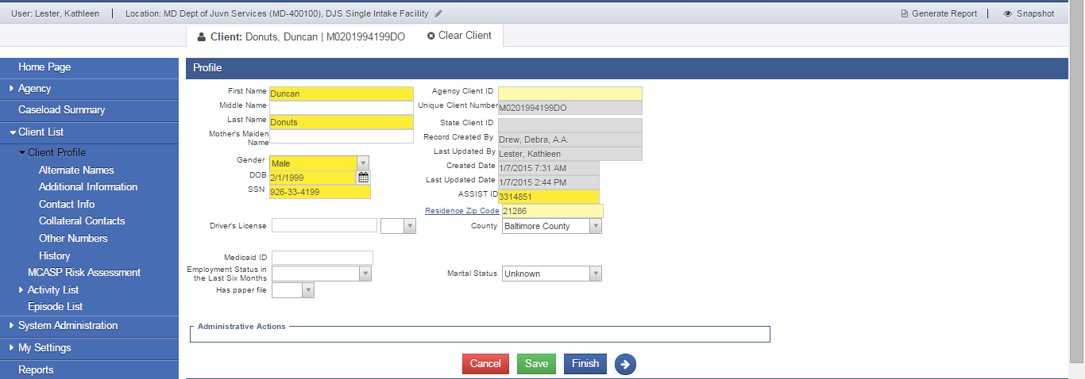

Creating a New Client in METS

Do NOT create a client in METS: All clients are created in ASSIST first and automatically created in METS. As of METS Release 17.22 in June 2015 ALL clients are messaged from ASSIST to METS. If you cannot find your client, DO NOT enter the client in METS, return to ASSIST to be sure the information is correct in ASSIST and update any information or create a new client in ASSIST. If you still cannot find your client, please contact the DJS Help Desk.

Logging Out of METS

- Log out of METS by clicking on the Logout link.

Note: Do NOT click on the X to close METS! Clicking on the X will disable your account.

Accountability Incentive Management in METS

Course Objectives:

At the end of this module, the trainee will be able to perform the following:

- Understand how to enter a CD Sanction in METS
- Understand how the Recommended Infraction Level is calculated
- Generate a Sanctions/Incentive Report
- Understand how to request an Override for the Response

Accountability & Incentives Management (AIM) Screen

Accountability & Incentives Management (AIM) is a structured array of choices to use in response to behaviors exhibited by youth under community supervision. Sanctions are penalties to deter undesirable behaviors, where the change in response is determined by the youth’s progress toward the severity of non-compliant or delinquent behavior and CD Level.

Document a CD Sanction

- For each sanction , click Sanctions & Incentives on the left menu tree and enter the corresponding information.

- Click Add New Sanction CD to enter new Community Detention sanction.
- Enter the Infraction Determination Guide information, including Behavior, Behavior Date, Frequency of Violation, Duration of Violation, Community Safety and Compliance with Conditions.

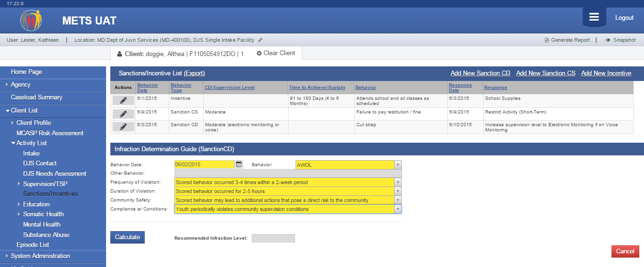
- Then click Calculate, METS will calculate the Recommended Infraction Level.

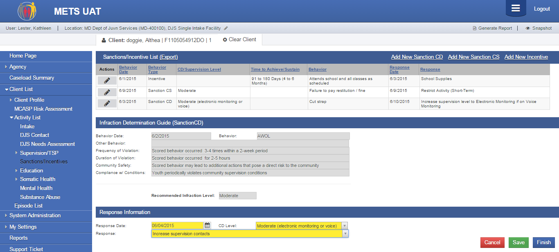
- The Recommended Infraction Level is calculated and Response Information section is activated below. Note: See Graduated Response Grid in Appendix A, for a full list of appropriate DJS responses to behaviors.
- Enter the Response Date, CD Level, and Response. All fields are required and must be completed to save the record.
- Click to stay on this same page or click to return to the Sanctions/Incentives List. Note: Clicking Save or Finish will lock the record, only click Save or Finish when you are certain that the documented information is accurate.
- Clicking Cancel will cancel the entire record, including information entered into the Infraction Determination Guide.

Deleting a Record

Once a response is documented, the record is locked and uneditable. There are two actions you can choose to update or modify the record.

- If the record was entered in error, the record can be deleted. To delete a record, from the Sanctions & Incentives List screen move your cursor over the , and select Delete.
- A confirmation message appears, click yes.

The record is now deleted.
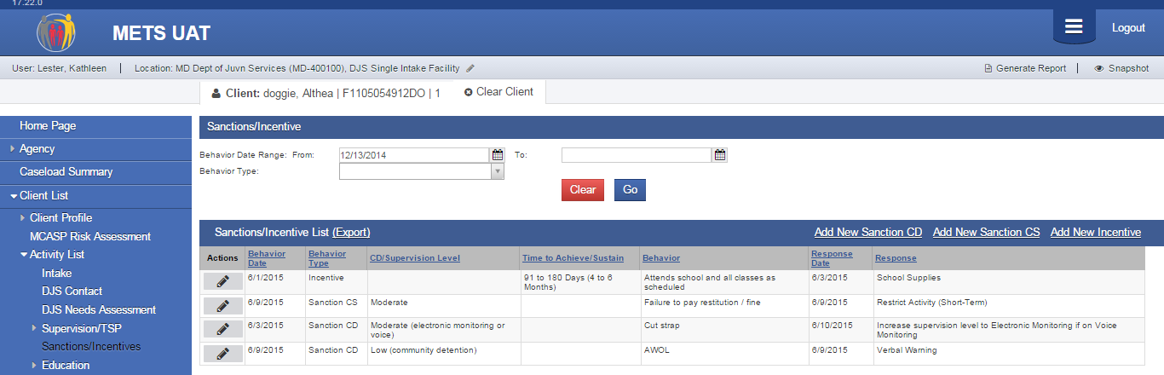

Requesting an Override to Modify the Response

In certain circumstances, the list of available responses may not be appropriate for the behavior due to extenuating factors. In these circumstances, contact your supervisor.

Override Down

Your supervisor will have the ability to Override Down, expanding the list of response options, to those available for the recommended infraction level, as well as the lower level infraction. For example, if the recommended infraction level was moderate, the supervisor will be able to select from the list of moderate and low responses.

Override Up

If there is a need to change the response to a higher level, your supervisor will contact your ARD or RD to change the response to a higher level. For example if the infraction level was moderate, the ARD/RD will be able to select from the list of moderate and high responses.

Generate a Report in METS

There are two ways in which to generate a report of the sanctions and incentives in METS, generate a canned report that provides a list of all sanctions and incentives. Or export the data to an Excel file.

- To generate a report of all the Sanctions/Incentives, click Generate Report from the upper right hand corner.

METS generates a report of all Sanctions & Incentives in descending order.

- Or you can generate a report by date range or by behavior type (Sanction CD, Sanction CS or Incentive).
- Select the date range from and to (for example 1/1/15 to 6/10/15)
- Select the Behavior Type - Incentive, Sanction CD or Sanction CS (for example Sanction CD)

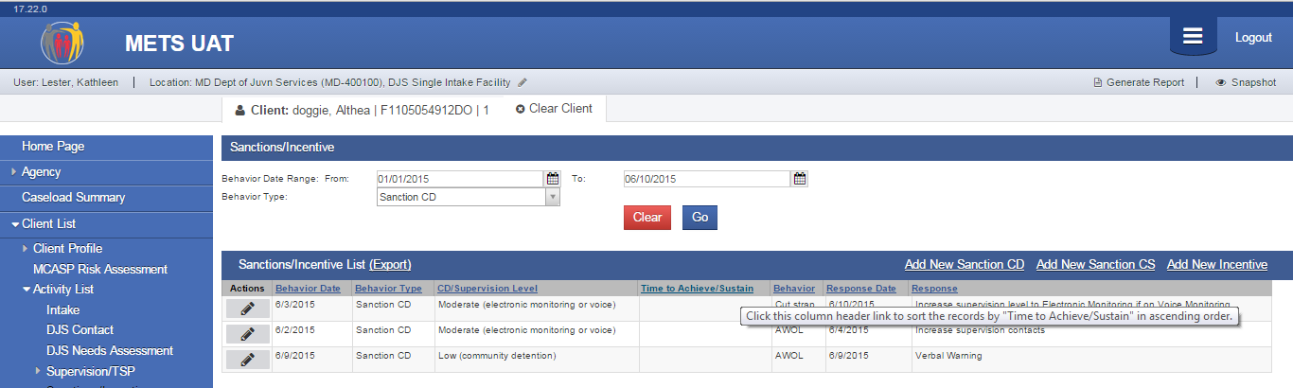
The report generated only displays CD Sanctions from 1/1/15 to 6/10/15.

- Additionally, data can be exported into an Excel file. Using the same filters as the report above.

And the data exported matches the search criteria, allowing you to use the data in an Excel file.
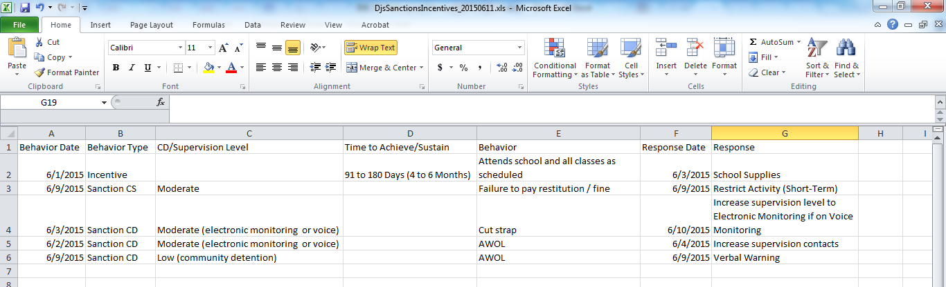

DJS Contacts (Bidirectional Messaging to/from ASSIST)

Contacts are now available in both ASSIST and METS, and messaging has been established so that entering a contact in one system automatically enters it in the other system. DJS staff can view all contacts for a client, enter contacts, edit contacts or lock a contact in either ASSIST or METS. If you are already working in ASSIST and need to enter a contact, you can enter it there, or if you are working in METS and need to enter a contact, you can enter it there.

- From the left menu, click DJS Contact. This brings you to the Contact List screen in METS.
- The list screen displays a list of contacts for the client. Note: The Selected Staff only lists staff members who have entered a contact for this client.
- The top portion of the screen allows the user to customize the list of contacts by date range, staff, location or contact status.
- To enter a new contact, click “Add New”.

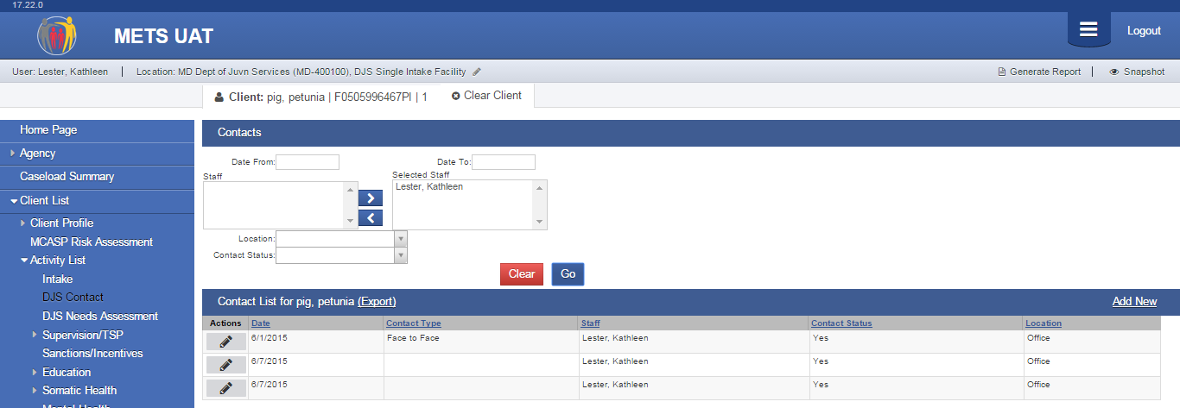
- The Date automatically defaults to today’s date, if you are entering a contact for a different date, modify the date.
- Complete as many fields on screen as you can. The fields in METS are the exact same fields as those in ASSIST.
- Click Click to stay on this same page or click to return to the Contacts List.

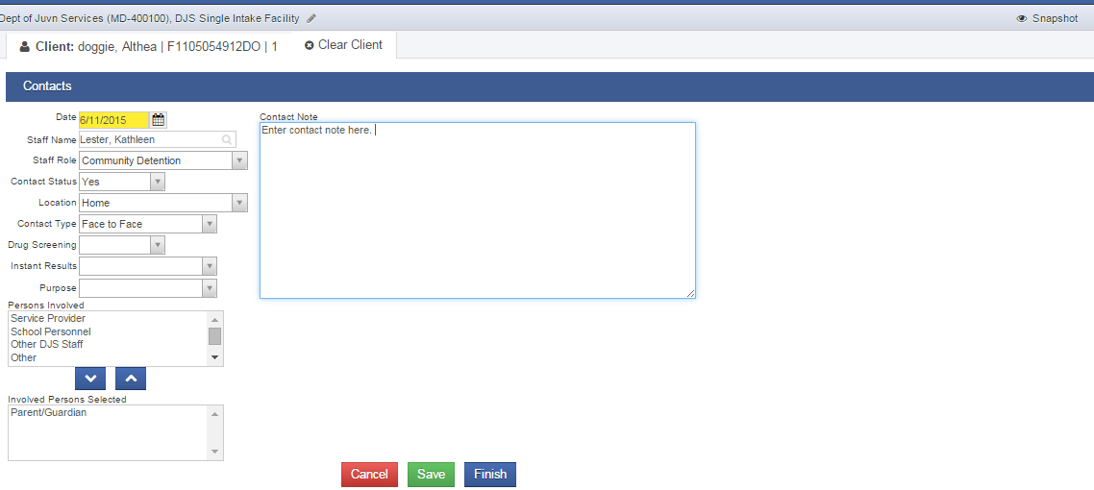
- Once the Contact has been saved, the record can also be locked. To lock a contact, making it uneditable, from the Contact screen, in the Administrative Actions box, click Lock Contact.

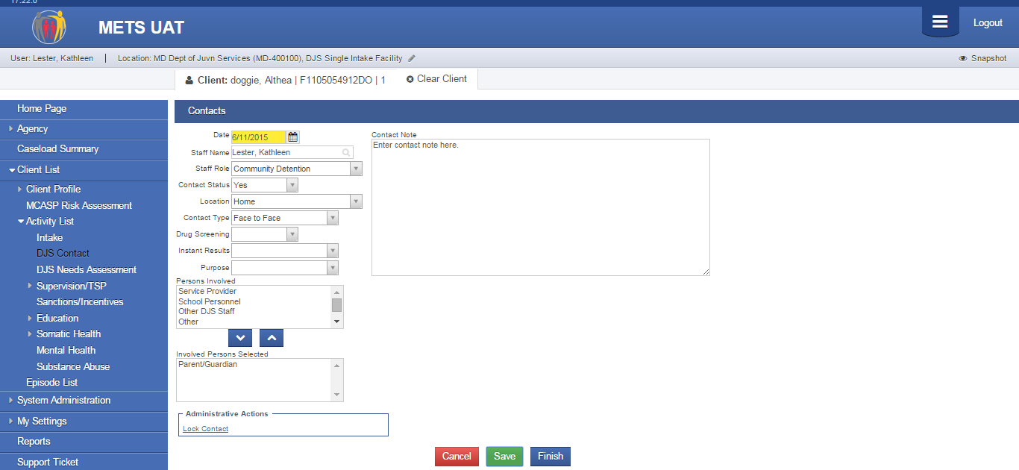
The record now becomes grayed out and uneditable.
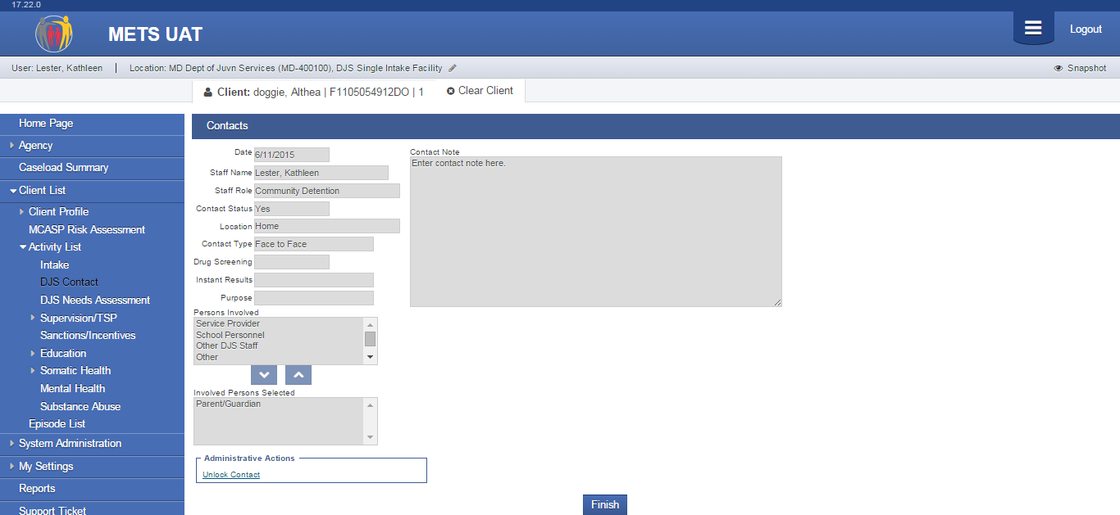

Generate a Contacts Report in METS

There are two ways in which to generate a report of the youth’s contacts in METS, generate a canned report that provides a list of all sanctions and incentives. Or export the data to an Excel file.

- To generate a report of Contacts by date range, enter the dates in the Date Range From and Date Range To fields and click Generate Report from the upper right hand corner. Note: the date fields default to the last 30 days.
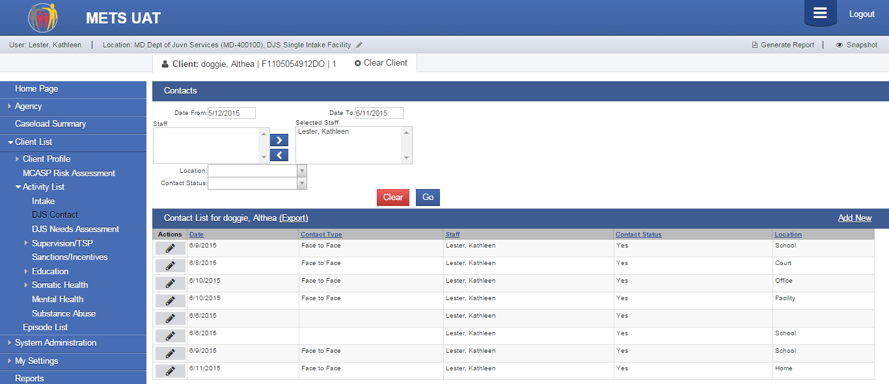
METS generates a report of all Contacts for the specified date range in descending order.
- Or you can generate a report by staff, location or contact status.
- Select the date range from and to (for example 1/1/15 to 6/10/15)
- Select the staff
- Select the location
- Select the Contact Status
- Click Go to filter your contact list
- Click Generate Report

The report generated only displays School contacts from 5/12/15 to 6/11/15 for Kathleen Lester, where Contact Status = Yes.

- Additionally, data can be exported into an Excel file. Using the same filters as the report above.
- Click Export.

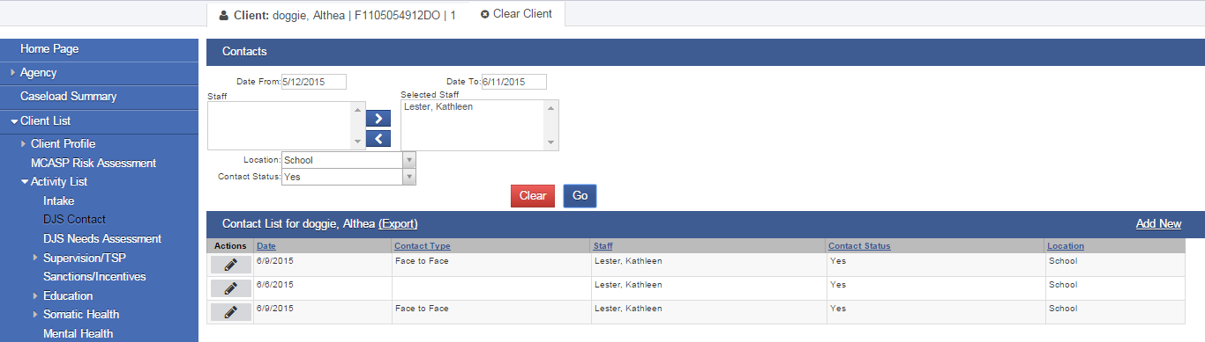

And the data exported matches the search criteria, allowing you to use the data in an Excel file.

Appendix A – Graduated Response Grid (Community Detention)

